# Setup Instructions

1. Open any VectorWorks file
2. Navigate to the Plug-in Manager
   1. Click on the Tools dropdown on the top left
   2. Hover over Plug-ins
   3. Click on Plug-in Manager…

1. Click on New
2. Select the Tool plug-in type and name the plug-in Create Manifest

1. Click on the newly created plug-in and click edit script
2. Change the script language form VectorScript to Python Script

1. Leave this window open and in a separate file explorer window find script.txt file located at \\crus-boston\CR Events\Memorial Union\Event Files\Manifest Software
   1. You can copy the above file location and past it into file explorer

1. Open the Scrip.txt and copy all the contents to your clipboard (Ctrl + A then Crtl + C)
2. Return to Vectorworks and paste the contents of your clipboard into the Script Editor (Crtl + V)
3. Click ok then click close to get out of the plug-in manager
4. Next navigate to the workspace editor

1. Click on the Tools tab

1. Click on all tools on the left side. Scroll Through the Tools on the left side until you find the create manifest tool with the wrench symbol. On the right side click on tool sets then click on the tool set currently selected on the left side of your screen. Scroll until you find the first tool currently in your tool set. For me it was Flyover.

1. Click and drag the Create Manifest tool above the tool you found on the right side (the flyover for me) then click ok
2. Click ok on the dialogue that pops up
3. After VectorWorks finishes updating the tool should show up on the left in your tool sets

# Known Issues

When getting an error click on view error output and scroll to the bottom. The last line is usually the most informative.

1. If getting an error message along the lines of ____ file not found delete the gen_py folder. The easiest way to do this is to open file explorer and type %temp%/gen_py and hit enter. Next hit the arrow pointing up in the top left corner. The gen_py folder should be highlighted so you can just press delete.

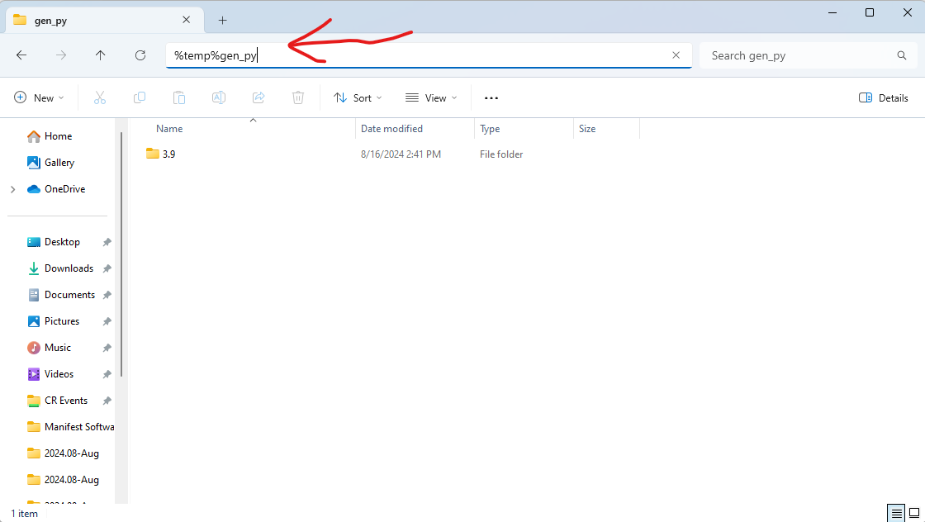

1. If none of these work contact Josiah or IT with a screenshot of the error output.

# How To Use the Tool

1. Click on the tool in the Tool Sets section on the left
2. Click anywhere on the VectorWorks diagram you wish to make a manifest of
3. A word document should be automatically created for you. If it’s not working or is slow it sometimes helps to open up word manually, but sometimes it just takes a while especially the first time the tool is run.

# Update Instructions

1. Open any VectorWorks file
2. Navigate to the Plug-in Manager
   1. Click on the Tools dropdown on the top left
   2. Hover over Plug-ins
   3. Click on Plug-in Manager…

1. Click on the Create Manifest plug-in and click edit script
2. Leave this window open and in a separate file explorer window find script.txt file located at \\crus-boston\CR Events\Memorial Union\Event Files\Manifest Software
   1. You can copy the above file location and past it into file explorer

1. Open the Scrip.txt and copy all the contents to your clipboard (Ctrl + A then Crtl + C)
2. Return to Vectorworks and paste the contents of your clipboard over the script in the Script Editor (Crtl + A then Crtl + V)
3. Click ok then click close to get out of the plug-in manager
4. Next go back to your file explorer and paste in %temp% and find the gen_py directory and delete the whole directory

# How To Edit the Manifest Format

1. In a file explorer window find the (Building Name) Manifest Template.csv file located at \\crus-boston\CR Events\Memorial Union\Event Files\Manifest Software
   1. You can copy the above file location and past it into file explorer

1. Add a new row by right clicking on the row you want to be below yours and clicking insert

1. Fill in each column with the relevant information
   1. **Section** – which part of the page do you want this line on with five options: topOfPage, listPortion, notesPortion, schedulePortion, and contactPortion
      1. **topOfPage** starts at the beginning of the page and ends right before all the instructions
      2. **listPortion** is the main portion of the manifest. It includes all the instructions in list form
      3. **notesPortion** is all of the bullet point notes
      4. **schedulePortion** is mainly filled out manually after the manifest is auto generated and is the agenda for the event
      5. **contactPortion** is where all the contact info for people relevant to the event go. Brianna’s information is autofilled out currently.
   2. **Text** – The text you would like your section to fill out, with GAP being a special type of text.
      1. GAP indicates you would like an additional empty line or a tab somewhere as a blank Text cell would break the program, meaning if you don’t set linebreak after or tab before to TRUE the GAP will do nothing
   3. **Bold** – Like most of the rest of the columns Bold has two options TRUE or FALSE. When TRUE the text in the Text portion will be bolded.
   4. **Underline** – only TRUE or FALSE. When TRUE the text in the Text portion will be underlined.
   5. **Linebreak** **after** – only TRUE or FALSE. When TRUE the text in the Text portion will be the last text in the current line (the program will hit the enter key after the text). Also used with GAP to create blank lines.
   6. **Tab** **before** – only TRUE or FALSE. When TRUE the program will hit the tab key before writing the text in the Text portion. This is used to center text, especially text with other text on the same line as it. Combine with GAP to avoid underlining the empty space in certain areas
   7. **listLevel** – A number indicating what level of a list the entry would be. For example, in this list “Fill in each column with the relevant information” would have a 1 the Text line would have a 2 and the topOfPage line would have a 3. 0s are used as a place holder for text that is not in a list, but it doesn’t matter what number used if they’re not in a list.
   8. **Delay** – only TRUE or FALSE. When TRUE the text isn’t added until after the autogenerated text from the diagram is added. Only currently matters for the listPortion section.

# How Add Symbols/Edit Symbols Text

1. In a file explorer window find the (building name) symbols.csv file located at \\crus-boston\CR Events\Memorial Union\Event Files\Manifest Software
   1. You can copy the above file location and past it into file explorer

1. Add at the bottom
2. Fill in each column with the relevant information
   1. **Name** – The name of the symbol in VectorWorks (must match exactly to work).
   2. **Before Text** – The text that goes before the autogenerated number of the object present, usually Setup.
   3. **After Text** – The text that goes after the autogenerated number of the object present, usually Setup.
   4. **Ignore** – only TRUE or FALSE. When TRUE the object does not contribute to the manifest, usually used for things like the trashes. Currently the same as not filling out a column for the object, however in the future this value might need to be utilized so it would be better to fill out a row for each symbol regardless.